import numpy as np

import matplotlib.pyplot as plt

# Generate two signals

t = np.linspace(0, 1, 1000, endpoint=False) # Time vector

signal1 = np.sin(2 * np.pi * 5 * t) # Sine wave with frequency 5 Hz

signal2 = 0.5 * np.cos(2 * np.pi * 10 * t) # Cosine wave with frequency 10 Hz

# Add the signals

sum_signal = signal1 + signal2

# Plot original signals and the sum

plt.figure(figsize=(10, 4))

plt.subplot(3, 1, 1)

plt.plot(t, signal1, label='Signal 1')

plt.legend()

plt.subplot(3, 1, 2)

plt.plot(t, signal2, label='Signal 2')

plt.legend()

plt.subplot(3, 1, 3)

plt.plot(t, sum_signal, label='Sum of Signals')

plt.legend()

plt.tight_layout()

plt.show()

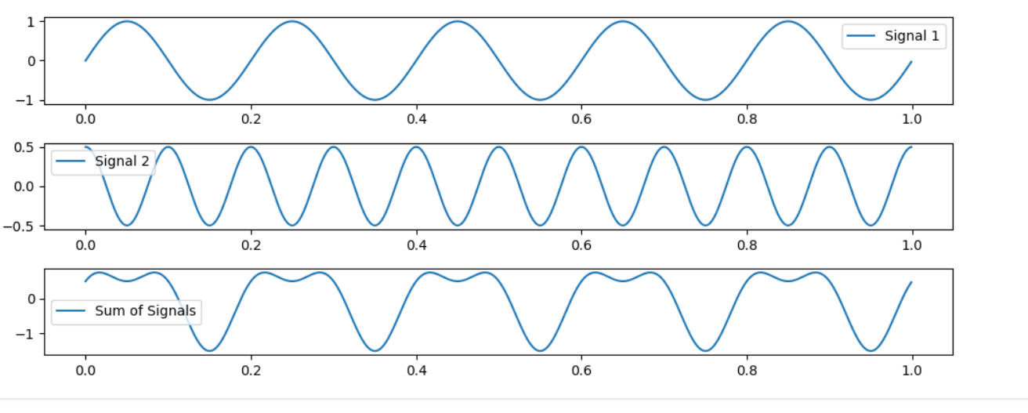

import numpy as np

import matplotlib.pyplot as plt

from scipy.fft import fft

# Example: Generate a signal with two frequencies

fs = 1000  # Sampling rate in Hz

t = np.arange(0, 1, 1/fs)  # Time vector

frequency1 = 50  # Frequency in Hz

frequency2 = 120  # Frequency in Hz

signal = 0.7 * np.sin(2 * np.pi * frequency1 * t) + 0.3 * np.sin(2 * np.pi * frequency2 * t)

n = len(signal)  # Number of samples

freq = np.fft.fftfreq(n, d=1/fs)  # Frequency axis

fft_values = fft(signal)  # Compute the FFT

magnitude_spectrum = np.abs(fft_values) / n  # Normalize by the number of samples

# Identify the index of the maximum amplitude in the spectrum

max_index = np.argmax(magnitude_spectrum)

dominant_frequency = freq[max_index]

# Plot the signal

plt.subplot(2, 1, 1)

plt.plot(t, signal)

plt.title('Digital Signal')

plt.xlabel('Time (s)')

plt.ylabel('Amplitude')

# Plot the frequency spectrum

plt.subplot(2, 1, 2)

plt.plot(freq, magnitude_spectrum)

plt.title('Frequency Spectrum')

plt.xlabel('Frequency (Hz)')

plt.ylabel('Amplitude')

plt.tight_layout()

plt.show()

print("Dominant Frequency: {:.2f} Hz".format(dominant_frequency))

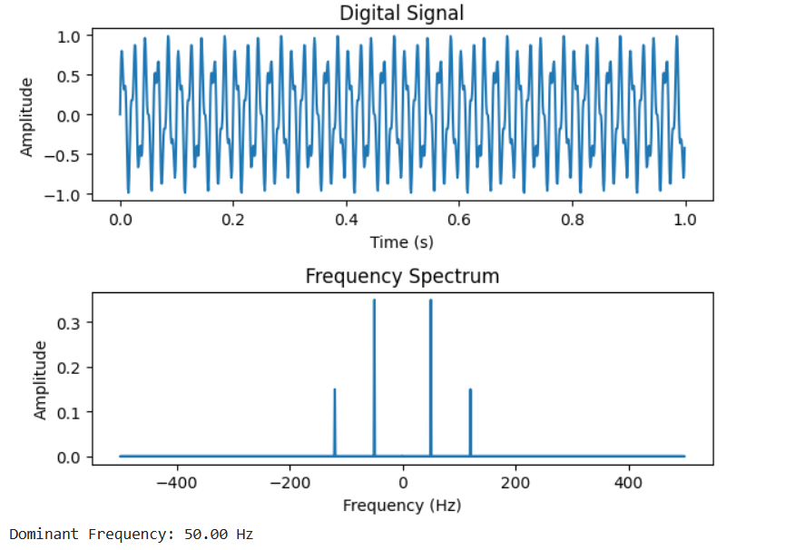

**Example:**

import numpy as np

import matplotlib.pyplot as plt

from scipy.signal import butter, lfilter

# Generate a sample signal (sine wave with noise)

fs = 1000 # Sampling frequency

t = np.linspace(0, 1, fs, endpoint=False) # Time vector

f_signal = 5 # Frequency of the signal

signal = np.sin(2 * np.pi * f_signal * t) + 0.5 * np.random.normal(size=len(t))

# Plot the original signal

plt.figure(figsize=(10, 4))

plt.subplot(2, 1, 1)

plt.plot(t, signal, label='Original Signal')

plt.title('Original Signal')

plt.xlabel('Time')

plt.ylabel('Amplitude')

plt.legend()

# Design a low-pass Butterworth filter

def butter_lowpass_filter(data, cutoff_freq, fs, order=4):

nyquist = 0.5 * fs

normal_cutoff = cutoff_freq / nyquist

b, a = butter(order, normal_cutoff, btype='low', analog=False)

y = lfilter(b, a, data)

return y

# Apply a low-pass filter to the signal

cutoff_frequency = 10 # Adjust this value based on your requirements

filtered_signal = butter_lowpass_filter(signal, cutoff_frequency, fs)

# Plot the filtered signal

plt.subplot(2, 1, 2)

plt.plot(t, filtered_signal, label=f'Filtered Signal (Cutoff={cutoff_frequency} Hz)')

plt.title('Filtered Signal')

plt.xlabel('Time')

plt.ylabel('Amplitude')

plt.legend()

# Display the plots

plt.tight_layout()

plt.show()

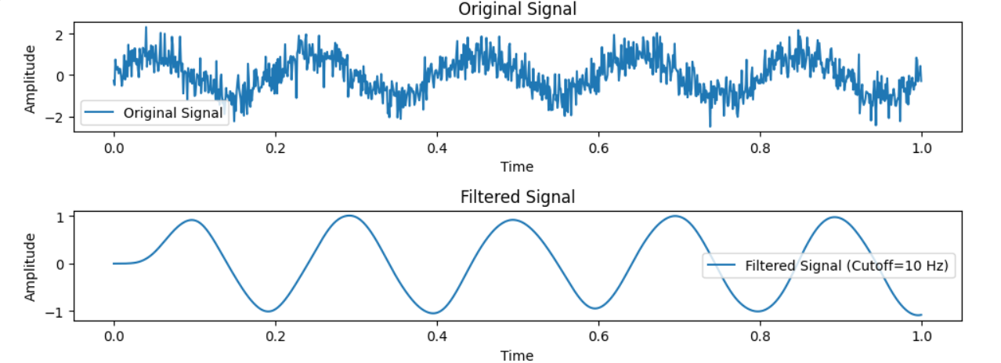

Example:

import numpy as np

import matplotlib.pyplot as plt

# Function to generate a composite signal

def generate_composite_signal(duration, sampling_rate, frequencies, amplitudes):

t = np.linspace(0, duration, int(duration * sampling_rate), endpoint=False)

signal = np.zeros_like(t)

for freq, amp in zip(frequencies, amplitudes):

signal += amp * np.sin(2 * np.pi * freq * t)

return t, signal

# Function to compute the frequency spectrum using Fourier Transform

def compute_frequency_spectrum(signal, sampling_rate):

n = len(signal)

freq = np.fft.fftfreq(n, d=1/sampling_rate)

fft_values = np.fft.fft(signal)

magnitude_spectrum = np.abs(fft_values) / n # Normalize by the number of samples

return freq, magnitude_spectrum

# Parameters

duration = 1 # seconds

sampling_rate = 1000 # Hz

frequencies = [10, 30, 50] # Hz

amplitudes = [1, 0.5, 0.2]

# Generate a composite signal

time, composite_signal = generate_composite_signal(duration, sampling_rate, frequencies, amplitudes)

# Compute the frequency spectrum

freq, magnitude_spectrum = compute_frequency_spectrum(composite_signal, sampling_rate)

# Plot the original signal

plt.subplot(2, 1, 1)

plt.plot(time, composite_signal)

plt.title('Composite Signal')

plt.xlabel('Time (s)')

plt.ylabel('Amplitude')

# Plot the frequency spectrum

plt.subplot(2, 1, 2)

plt.plot(freq, magnitude_spectrum)

plt.title('Frequency Spectrum')

plt.xlabel('Frequency (Hz)')

plt.ylabel('Amplitude')

plt.tight_layout()

plt.show()

